SIT 103 – DATABASE FUNDAMENTALS:
TASK 8.2D PL/PSQL - Trigger, Procedure and Function
SUBMITTED BY – JASVEENA-224001588
QUES 1: 1. Write a procedure named PRC_ADD_CUSTOMER to add a new customer to the CUSTOMER table. The procedure will take four IN arguments which are values of the four columns of the CUSTOMER table for the new customer to be added.
CODE: CREATE OR REPLACE PROCEDURE PRC_ADD_CUSTOMER (
p_CUST_NUM IN CUSTOMER.CUST_NUM%TYPE,
p_CUST_LNAME IN CUSTOMER.CUST_LNAME%TYPE,
p_CUST_FNAME IN CUSTOMER.CUST_FNAME%TYPE,
p_CUST_BALANCE IN CUSTOMER.CUST_BALANCE%TYPE)
IS
BEGIN INSERT INTO CUSTOMER (CUST_NUM, CUST_LNAME, CUST_FNAME, CUST_BALANCE) VALUES (p_CUST_NUM, p_CUST_LNAME, p_CUST_FNAME, p_CUST_BALANCE);
END PRC_ADD_CUSTOMER;
/
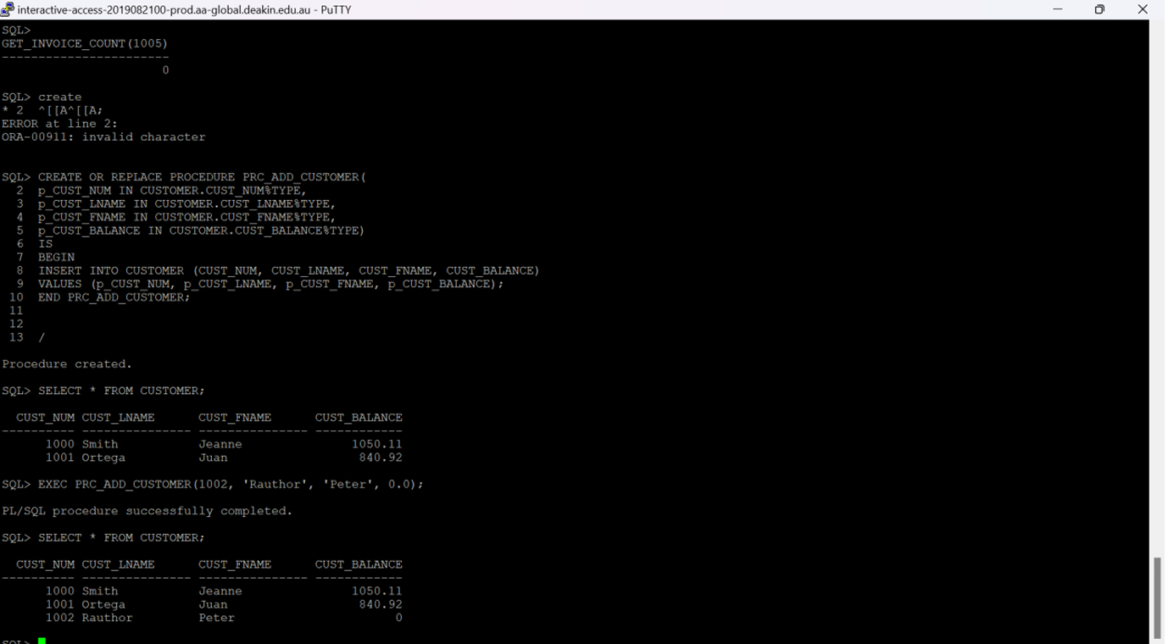

QUES 2: Write a function named get_invoice_count to retrieve the number of invoices for a given customer. Your function will take CUST_NUM as argument and returns the number of invoices for the customer.
CREATE OR REPLACE FUNCTION get_invoice_count(
p_CUST_NUM IN INVOICE.CUST_NUM%TYPE)
RETURN NUMBER IS
v_count NUMBER;
BEGIN
SELECT COUNT(*) INTO v_count FROM INVOICE WHERE CUST_NUM = p_CUST_NUM; RETURN v_count; END get_invoice_count;
/
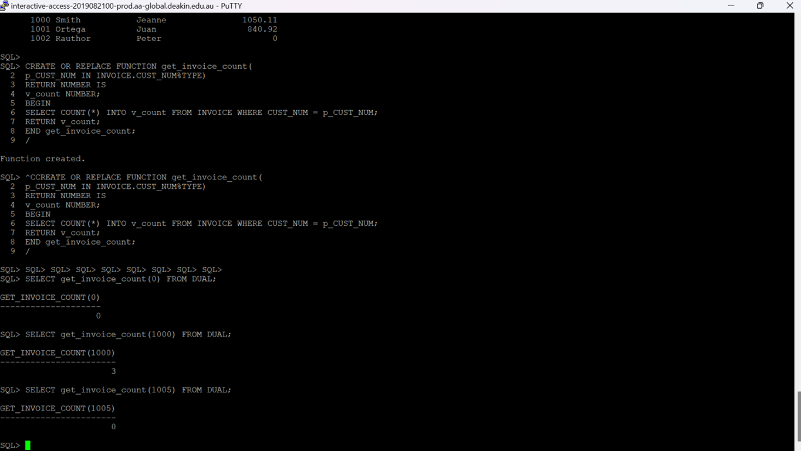
QUES 3: CREATE OR REPLACE TRIGGER TRG_UPDATE_CUST_BALANCE
AFTER INSERT ON INVOICE
FOR EACH ROW
BEGIN
UPDATE CUSTOMER SET CUST_BALANCE = CUST_BALANCE + :NEW.INV_AMOUNT
WHERE CUST_NUM = :NEW.CUST_NUM; END TRG_UPDATE_CUST_BALANCE;
/
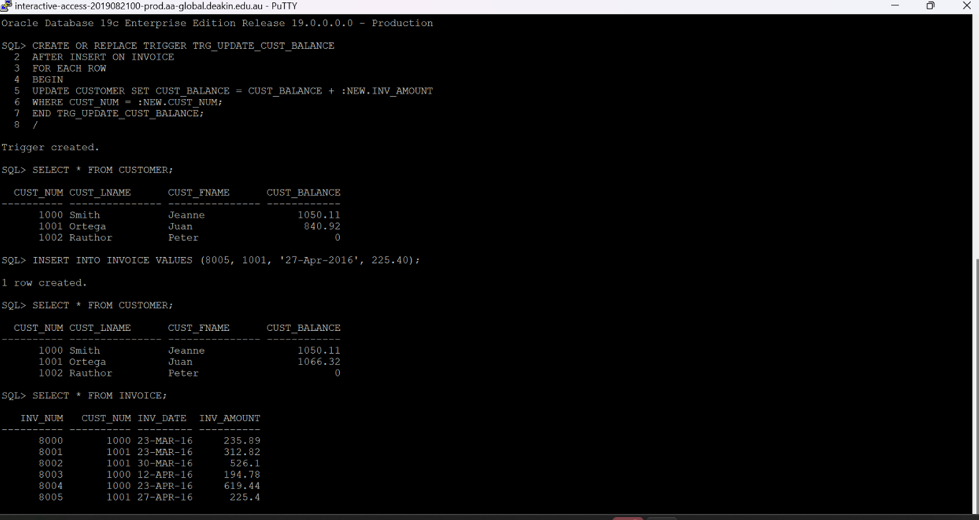

QUES 4: Write a procedure named PRC_ADD_INVOICE to add a new invoice record to the INVOICE table. The procedure will take four IN arguments which are values of the four columns of the INVOICE table for the new invoice to be added.
CREATE OR REPLACE PROCEDURE PRC_ADD_INVOICE (
p_INV_NUM IN INVOICE.INV_NUM%TYPE,
p_CUST_NUM IN INVOICE.CUST_NUM%TYPE,
p_INV_DATE IN INVOICE.INV_DATE%TYPE,
p_INV_AMOUNT IN INVOICE.INV_AMOUNT%TYPE)
IS
BEGIN
INSERT INTO INVOICE (INV_NUM, CUST_NUM, INV_DATE, INV_AMOUNT)
VALUES (p_INV_NUM, p_CUST_NUM, p_INV_DATE, p_INV_AMOUNT);
END PRC_ADD_INVOICE;
/
